Assignment 1

Data Exploration and Analysis

Semester 2 2026

Student Name: Matthew Rushmer
Student ID: 25288226

PAPER NAME: Data Analysis
PAPER CODE: COMP517
TOTAL MARKS: 100

Instructions:
- The following actions may be deemed to constitute a breach of the General Academic Regulations Part 7: Academic Discipline,
- Communicating with or collaborating with another person regarding the Assignment
- Copying from any other student work for your Assignment
- Copying from any third-party websites unless it is an open book Assignment
- Uses any other unfair means
- Please email your TA or lecturer if you have any technical issues with your Assessment/Assignment/Test submission on Canvas immediately.
- Attach your Assignment One Report from page 2 onwards.

Table of Contents
Table of Contents 1
List of Figures 3
List of Tables 4
1. Introduction & Dataset Summary 5
1.1 Dataset Overview 5
1.2 Data Types and Structure 6
1.3 Initial Summary Statistics 6
2. Data Pre-processing 8
2.1 Missing Values 8
2.2 Duplicate Records 9
2.3 Outlier Detection and Treatment 9
2.4 Outlier Visualisation 10
3. Data Exploration and Visualisation 12
3.1 Summary Statistics 12
3.2 Distribution of Numeric Variables 13
3.3 Distribution of Categorical Variables 14
3.4 Spread and Box Plots 16
4. Multivariate Analysis 17
4.1 Correlation Analysis 17
4.2 Categorical x Categorical Analysis 18
4.3 Aggregation Analysis 18
4.4 Relationship / Risk-Style Analysis 20
5. Conclusion 22
5.1 Summary of Key Findings 22
5.2 Challenges Encountered 22
5.3 Next Steps 23
References 24
Note on Code Submission 24

List of Figures
Figure 1: Boxplots of Pollutant Concentrations (Outlier Detection)
Figure 2: PM2.5: Outliers vs Non-Outliers (IQR method)
Figure 3: PM10: Outliers vs Non-Outliers (IQR method)
Figure 4: Distributions of the Nine Numeric Variables (Histograms)
Figure 5: Top 10 Countries by Number of Air Quality Records
Figure 6: Share of Records by Calendar Quarter
Figure 7: Boxplots of Weather Variables
Figure 8: Correlation Heatmap of Pollutant and Weather Variables
Figure 9: Record Count by Country (Top 5) and Calendar Quarter
Figure 10: Mean vs Median PM2.5 by Country
Figure 11: Air Quality Risk Score by Temperature Band

List of Tables
Table 1: First 5 Rows of the Raw Dataset (df.head())
Table 2: Data Dictionary for the Global Air Quality 2023 Dataset
Table 3: Missing Values by Column and Imputation Method Used
Table 4: Outlier Detection Bounds and Counts (IQR Method)
Table 5: Summary Statistics for Numeric Variables (Cleaned Dataset)
Table 6: Mean and Median PM2.5 by Country (Top 10 by Record Volume)
Table 7: Air Quality Risk Score by Temperature Band

1. Introduction & Dataset Summary
This report presents a full data analysis (EDA) of the “Global Air Quality 2023” dataset for COMP507 Assignment 1. It aims to show the practical skills needed to load, clean, explore and interpret a small-to-medium real-world-style dataset and to report the findings clearly and accurately. All code used to produce the results, tables and figures below is in the accompanying Python file: air_quality_eda.py.

1.1 Dataset Overview
- The dataset is a deliberately messy version of the Global Air Quality Dataset, originally published on Kaggle by WAQI786. It was modified by adding missing values, duplicate rows, outlying values, and inconsistent text formatting. This was done so we could clean and analyses it for this assignment.
- Before cleaning the dataset contains 30,450 rows and 12 columns.
- The dataset was loaded into a pandas DataFrame with pandas.read_csv(). It was then inspected with df.head() before any cleaning had began. Table 1 shows this raw preview. It already shows some of the inconsistency’s in the text. As an example “SYDNEY”. Aswell as blank value such as in NO2 for Johannesburg and PM10 for Sydney.
Table 1: First 5 Rows of the Raw Dataset (df.head())
City | Country | Date | PM2.5 | PM10 | NO2 | SO2 | CO | O3 | Temperature | Humidity | Wind Speed
Johannesburg | South Africa | 4/10/2023 | 127.51 | 175.1 |  | 13.02 | 1.7 | 196.41 | 27.46 | 51.14 | 10.26
Istanbul | Turkey | 4/22/2023 | 93.84 | 34.19 | 79.49 | 44.54 | 5.18 | 183.62 | 10.58 | 30.48 | 14.45
Berlin | Germany | 10/27/2023 | 52.03 | 181.8 | 45.05 | 30.12 | 0.96 | 155.61 | -4.09 | 96.9 | 2.49
SYDNEY | Australia | 6/10/2023 | 110.3 |  | 77.44 | 9.78 | 6.54 | 18.98 | 17.41 | 64.79 | 12.77
Dubai | UAE | 7/23/2023 | 120.24 | 48.98 | 98.82 | 6.27 | 6.98 | 133.94 | 13.11 | 31.61 | 5.0
- Each row is one air-quality reading for a given city, country and date in 2023. This covers 20 cities across 19 countries.
- The 12 columns are City, Country, Date, six pollutant measures (PM2.5, PM10, NO2, SO2, CO, O3) and three weather measures (Temperature, Humidity, Wind Speed). Table 2 give us a full Data explaination
Table 2: Data Dictionary for the Global Air Quality 2023 Dataset
Column | Type | Description
City | Text | City where the reading was recorded (20 unique cities after cleaning).
Country | Text | Country the city belongs to (19 unique countries).
Date | Date | Date the reading was taken (1 Jan – 28 Dec 2023).
PM2.5 | Numeric | Fine particulate matter concentration (diameter < 2.5 µm).
PM10 | Numeric | Coarse particulate matter concentration (diameter < 10 µm).
NO2 | Numeric | Nitrogen dioxide concentration.
SO2 | Numeric | Sulphur dioxide concentration.
CO | Numeric | Carbon monoxide concentration.
O3 | Numeric | Ground-level ozone concentration.
Temperature | Numeric | Ambient air temperature (°C).
Humidity | Numeric | Relative humidity (%).
Wind Speed | Numeric | Wind speed at the reading location.

1.2 Data Types and Structure
- City, Country and Date were stored as text values. The remaining nine columns (six pollutants and three weather variables) were stored as numeric values.
- The Date column needed converting from text to a proper date format. Values such as “10/27/2023” confirm the format is MM/D/DYYYY, not DD/MM/YYYY. Since no month can be 27. All 30,450 date values successfully follow this format
- City and Country needed capitalization error to be fixed and removal of any unnecessary spaces before they could be used reliably as categorical fields. No column had any wrong underlying datatypes or fields.

1.3 Initial Summary Statistics
- df.describe() on the raw data showed all six pollutant columns already bounded within realistic, fixed ranges (e.g. PM2.5 5.02–149.98, Humidity 10.01–99.99%). Means and medians were very close together. z
- df.isnull().sum() showed that missing values were confined entirely to the six pollutant columns. Each0020of which were missing between 4.84% and 5.25% of values. City, Country, Date and the three weather columns had none missing.

2. Data Pre-processing
This section reports every pre-processing decision and the reasoning behind it. This was made before any analyzing of the dataset

2.1 Missing Values
- Only the six pollutant columns had missing values: PM2.5 (1,552, 5.10%), PM10 (1,561, 5.13%), NO2 (1,593, 5.23%), SO2 (1,475, 4.84%), CO (1,496, 4.91%) and O3 (1,600, 5.25%). See Table 3.
- The first thing that was checked was skewness of each column. All six pollutant columns had a skew between −0.02 and 0.02. This is essentially symmetric. So mean value was used throughout. The mean value is the most appropriate choice for symmetric data from a statistical analysis. The median is only preferred when a distribution is skewed.
- The mean used was calculated separately for each Country. It was not a single dataset-wide mean. An earlier version of my analysis I used one global mean, but that repeated a fixed value across every country’s rows and did not accurately communicate the per-country comparison.
- No rows or columns were dropped. Missing data in any single column never exceeded 5.25%. Since this is below the 5–10% threshold at which removal is typically preferred over imputation.
Table 3: Missing Values by Column and Imputation Method Used
Column | Missing Count | Missing % | Method Used
PM2.5 | 1,552 | 5.10% | Per-country mean imputation
PM10 | 1,561 | 5.13% | Per-country mean imputation
NO2 | 1,593 | 5.23% | Per-country mean imputation
SO2 | 1,475 | 4.84% | Per-country mean imputation
CO | 1,496 | 4.91% | Per-country mean imputation
O3 | 1,600 | 5.25% | Per-country mean imputation
City / Country / Date / Temperature / Humidity / Wind Speed | 0 | 0.00% | None needed

2.2 Duplicate Records
- A total of 13,897 of the 30,450 rows (45.64%) were exact duplicates, with all 12 columns identical. This matches the dataset’s documentation, which states that duplicate and near-duplicate rows were deliberately injected.
- A wider check (rows sharing only the same City, Country and Date, a natural composite key for this dataset) found 25,375 matching rows, far more than the exact-duplicate count. So roughly 11,478 rows share a city and date with another row but report different pollutant or weather readings.
- Decision: only the 13,897 exact duplicates were removed, using drop_duplicates(), leaving 16,553 rows. Rows that shared a City + Country + Date key but differed in their measurements were kept, because a city could legitimately have multiple monitoring stations or repeat readings on the same day. This dataset gives no timestamp or station ID to tell them apart. Because of this we can not remove them as they could be genuine measurements.

2.3 Outlier Detection and Treatment
- The Interquartile Range method (flagging values below Q1 - 1.5×IQR or above Q3 + 1.5×IQR) was applied to all nine numeric columns on the data that had the duplicates removed. Table 4 gives the exact bounds used for each column.
- Result: zero outliers were detected in every single numeric column. This was cross-checked on PM2.5 using the z-score method (|z| > 3). This also return no outlier values.
- Deeper Dive: The minimum and maximum of every pollutant and weather column sit at values which are very round and fixed( PM2.5 ranges exactly 5.02–149.98, Humidity exactly 10.01–99.99%, Wind Speed exactly 0.5–20). This should indicate a bit of doubt from us. It suggests the values were generated or constrained within fixed values, rather than drawn from a distribution with a genuine long tail. Since most of the data sits packed tightly in the middle, the IQR method draws its "normal range" way wider than the data actually spans. So even the biggest and smallest values in the whole dataset still fall inside that range, and nothing gets flagged as an outlier even though the data's own documentation says outliers were deliberately added in.
- Decision: since neither method found statical outliers which were genuine, no values were removed or transformed on outlier grounds. This result is reported here as a meaningful finding and should not glossed over.
- A check for physically impossible values was also run (Humidity outside 0–100%, negative Wind Speed). Zero rows were removed, confirming the weather columns are already within valid physical ranges.
Table 4: Outlier Detection Bounds and Counts (IQR Method)
Column | Lower Bound | Upper Bound | Outliers Found
PM2.5 | -53.02 | 208.31 | 0
PM10 | -67.83 | 276.97 | 0
NO2 | -33.45 | 136.84 | 0
SO2 | -18.61 | 69.20 | 0
CO | -3.98 | 13.98 | 0
O3 | -67.58 | 277.94 | 0
Temperature | -35.41 | 65.07 | 0
Humidity | -35.04 | 144.37 | 0
Wind Speed | -9.19 | 29.66 | 0

2.4 Outlier Visualisation
Figures 2 and 3 plot every PM2.5 and PM10 readings coloured by whether the IQR method detected it as an outlier. As expected from Table 4 every point in both plots is detected as not being outliers. Both scatterplots show a clearly visible horizontal band of points around 75–80 for PM2.5. This band is the roughly 844 value points that survived de-duplication. It is now visible as an artificial cluster rather than a genuine reading. Because imputation was done per-country rather than with one shared number, this cluster is a tight band of about 19 slightly different country-mean values, not a single exact line. That is visible proof that the fix in Section 2.1 changed the underlying values, even though the countries PM2.5 means are close enough together that the band still looks like one line at this scale. Figure 1 which is the boxplots of all six pollutants, confirms the this outlier result: no whisker points extend beyond the box for any pollutant.
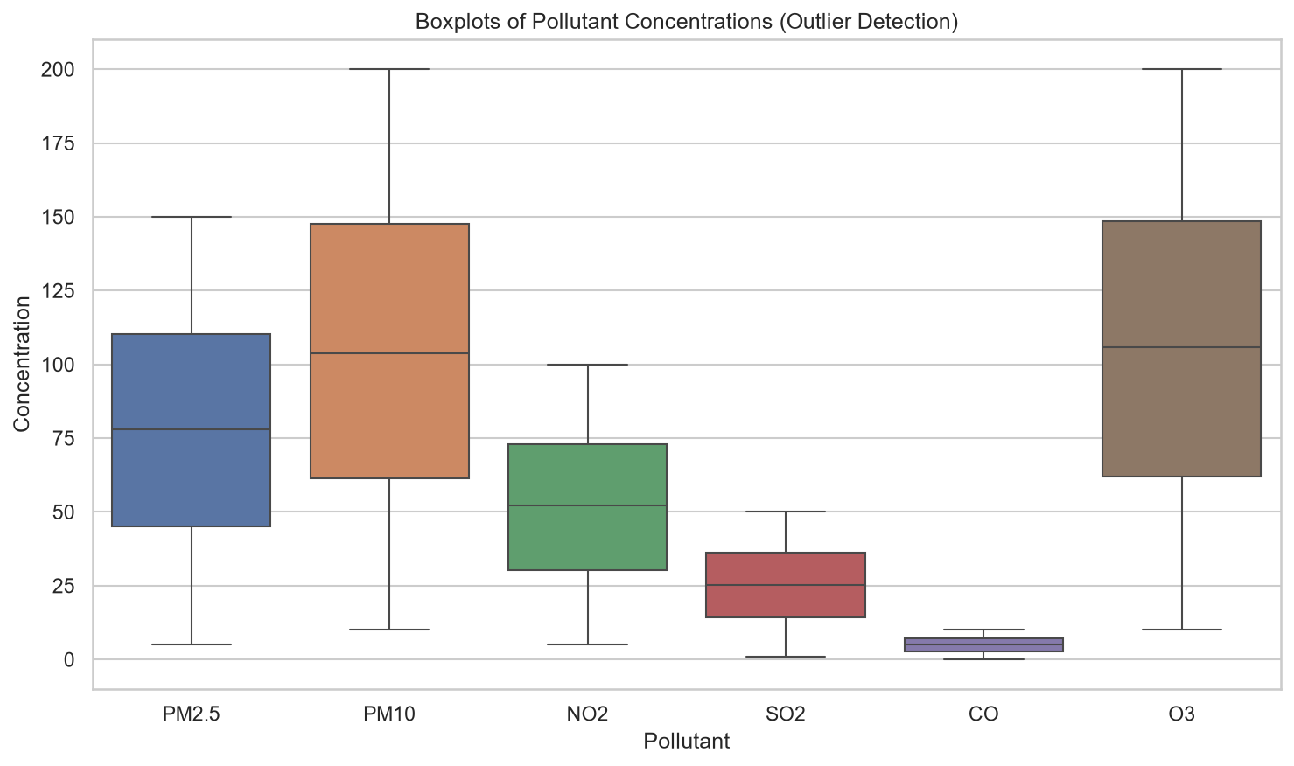
Figure 1: Boxplots of Pollutant Concentrations (Outlier Detection)
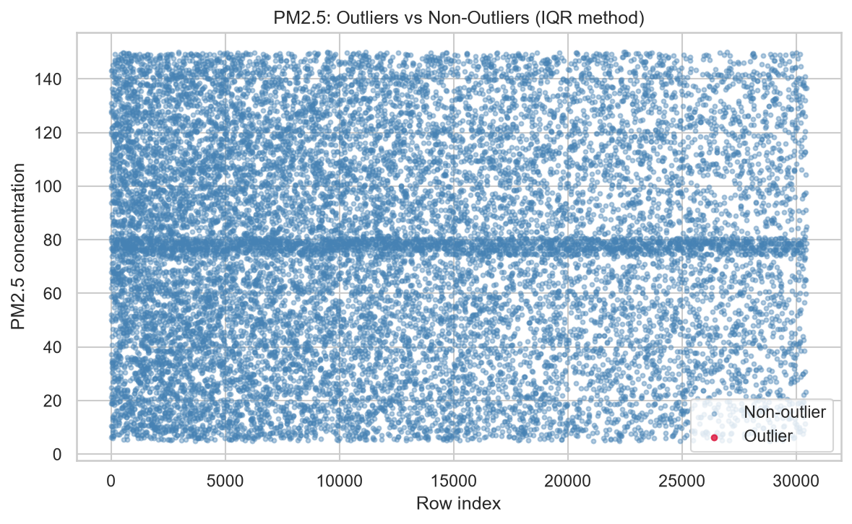
Figure 2: PM2.5: Outliers vs Non-Outliers (IQR method)
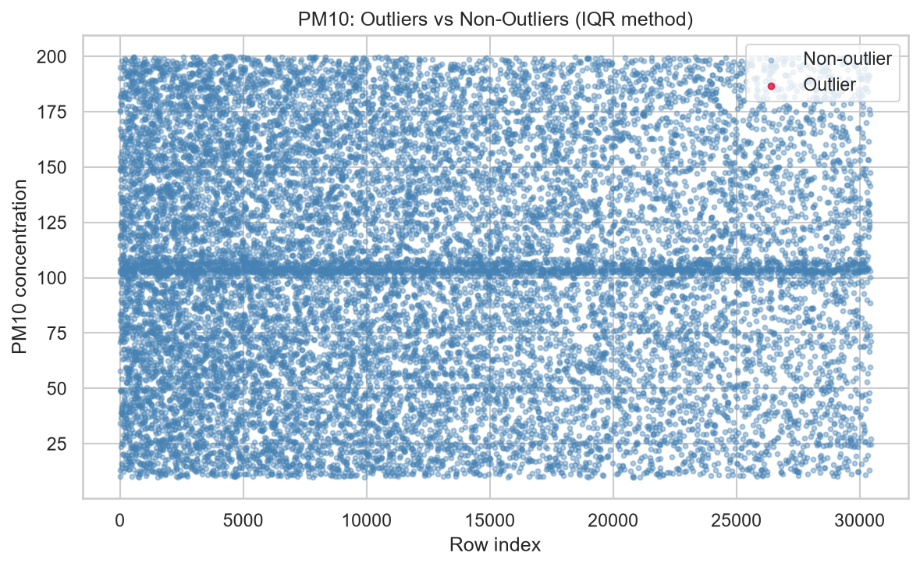
Figure 3: PM10: Outliers vs Non-Outliers (IQR method)

3. Data Exploration and Visualisation
This section explores the cleaned, de-duplicated dataset (16,553 rows) using summary statistics and a range of univariate visualisations.

3.1 Summary Statistics
Table 5: Summary Statistics for Numeric Variables (Cleaned Dataset)
Variable | Mean | Median | Std Dev | Min | Max
PM2.5 | 77.79 | 78.12 | 40.07 | 5.02 | 149.98
PM10 | 104.40 | 103.67 | 52.55 | 10.00 | 200.00
NO2 | 52.08 | 52.16 | 25.97 | 5.01 | 100.00
SO2 | 25.29 | 25.25 | 13.43 | 1.00 | 49.99
CO | 5.04 | 5.03 | 2.73 | 0.10 | 10.00
O3 | 105.37 | 105.93 | 52.49 | 10.04 | 200.00
Temperature | 14.93 | 14.88 | 14.47 | -10.00 | 40.00
Humidity | 54.74 | 54.58 | 25.97 | 10.01 | 99.99
Wind Speed | 10.28 | 10.37 | 5.62 | 0.50 | 20.00

- For all nine numeric variables the mean and median are close together. As an example PM2.5: 77.79 vs 78.12 and for Temperature: 14.93 vs 14.88. This confirms there is a near-symmetric distribution already which was already suggested by the skewness check we did at the start.
- Standard deviations are large relative to each of the variable’s range (PM2.5’s std of 40.07 is around half its mean). This show values spread evenly across the full range, rather than simply clustering around one standard value. This pattern is more consistent with random or synthetic generation then real atmospheric measurement, where pollutant levels usually stick closely together which the occasional spike.

3.2 Distribution of Numeric Variables
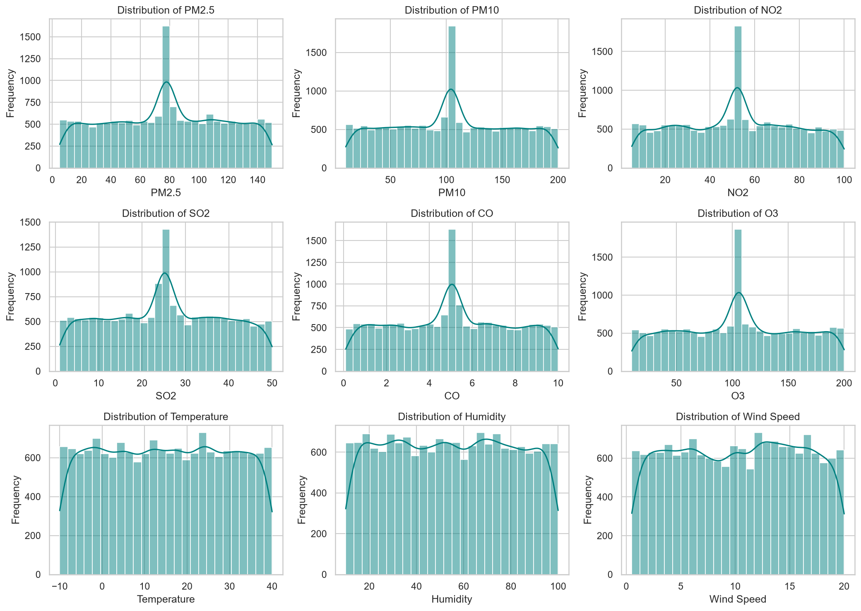
Figure 4: Distributions of the Nine Numeric Variables (Histograms)
- All nine histograms show a near-uniform/flat shape across their full range. No variable shows a more normal distribution of bell-curve
- Every one of the six pollutant histograms has one sharp central spike that the three weather variables do not have. This spike is cause by the imputation of about 5% of each pollutant column in Section 2.1. Because the imputing of the values is done per-country he 19 country-specific values which were filled in are not identical, but they sit close enough together to land in the same one or two histogram bins. The result is a single visible spike, not a genuine feature of the underlying data.

3.3 Distribution of Categorical Variables
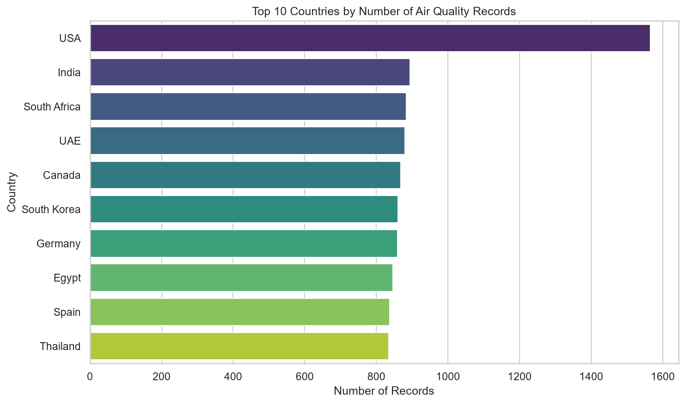
Figure 5: Top 10 Countries by Number of Air Quality Records
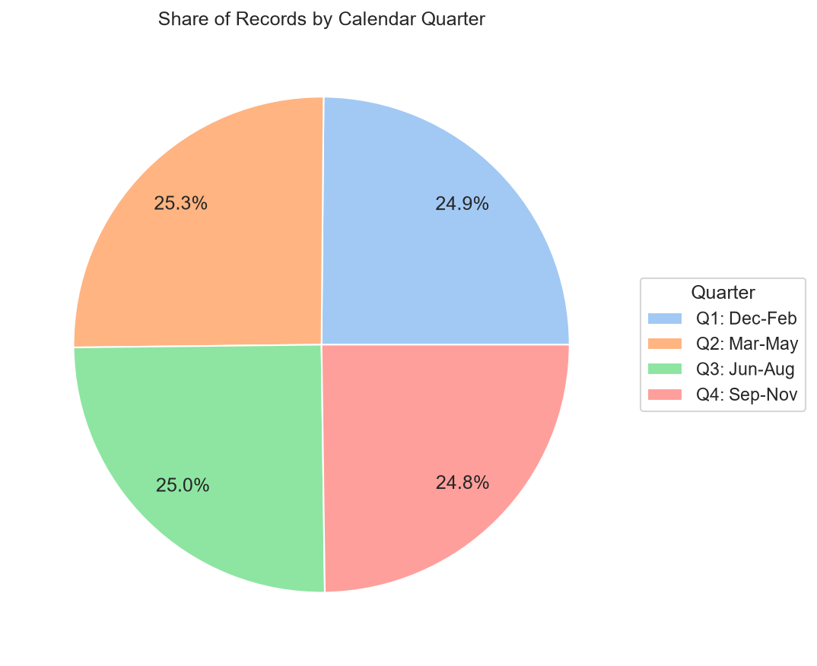
Figure 6: Share of Records by Calendar Quarter
- The USA supplies by far the most records after cleaning (1,565). This is roughly double the next most-represented countries (India - 894, South Africa - 884, UAE - 880). The remaining countries are fairly evenly represented. Their value sit between 830 and 870 records each, across 19 countries and 20 cities in total.
- Records are split almost perfectly evenly across the four calendar quarters (24.8%–25.3% each). This suggests the underlying dates were generated uniformly at random across 2023, with no time-of-year bias in when readings were recorded. This report uses quarters rather than hemisphere-specific season names. This is done since the dataset mixes Northern-Hemisphere countries with Southern-Hemisphere countries for which would mean that when it winter in one country it could be summer in another. Therefor our record would be inaccurate.

3.4 Spread and Box Plots
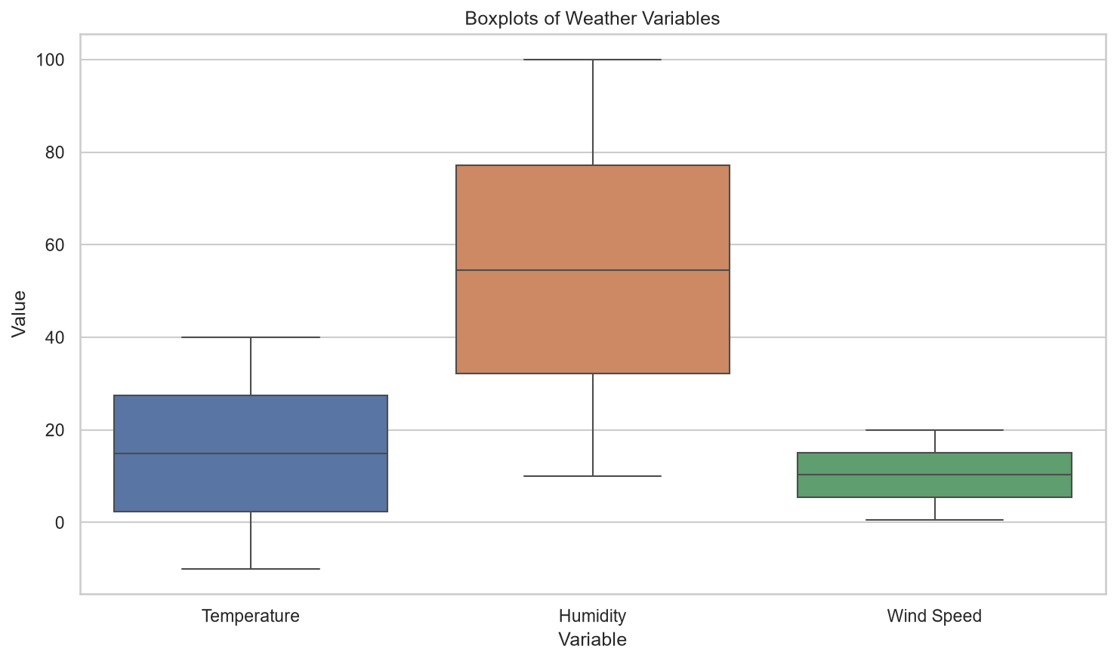
Figure 7: Boxplots of Weather Variables
The weather-variable boxplots mirror the pollutant boxplots in Figure 1. The have similar widths, evenly spread interquartile ranges, median lines close to the centre of each box, and no points beyond the whiskers. This matches the near-uniform, no-outlier pattern already found across every numeric column in this dataset.

4. Multivariate Analysis

4.1 Correlation Analysis
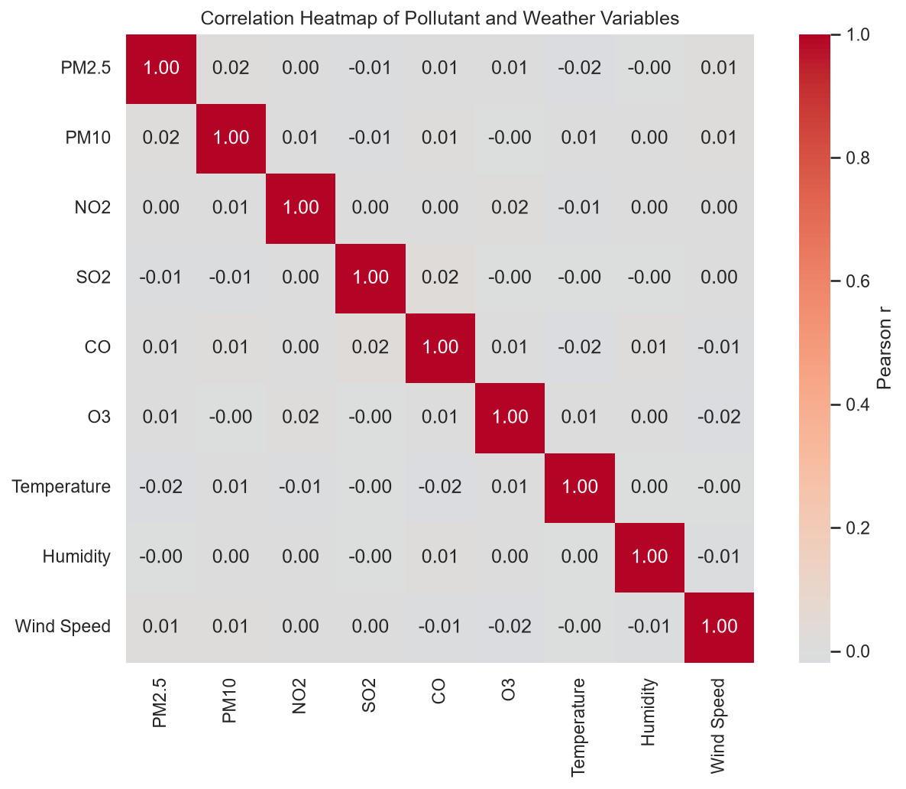
Figure 8: Correlation Heatmap of Pollutant and Weather Variables
- Every pairwise Pearson correlation between the nine numeric variables lies between −0.02 and 0.02. This is basically 0 and no pair comes close to the |r| > 0.7 threshold for a strong correlation and none even exceeds |r| = 0.02.
- In real-world air-quality data, related pollutants such as PM2.5 and PM10 typically show at least a moderate positive correlation. This means they typically would rise and fall together since they have the same source. Wind speed typically shows a negative correlation with pollutant concentration. This is because wind disperses pollutants. The complete lack of any such pattern here is strong indication that every column in this dataset was generated/ collected independently of the others, rather than through a physically coupled air-quality model. This is an important for anyone intending to use this dataset for the purpose of making predictions.

4.2 Categorical x Categorical Analysis
Variables chosen: Country and Quarter (calendar quarter) restricted to the five countries with the most records (USA, India, South Africa, UAE, Canada) for ease of reading.
Rationale: both are natural ways to group this air-quality data. A reasonable question to ask is whether more readings were collected in certain countries during certain parts of the year. As an example due to funding cycles or monitoring-station time spent running.
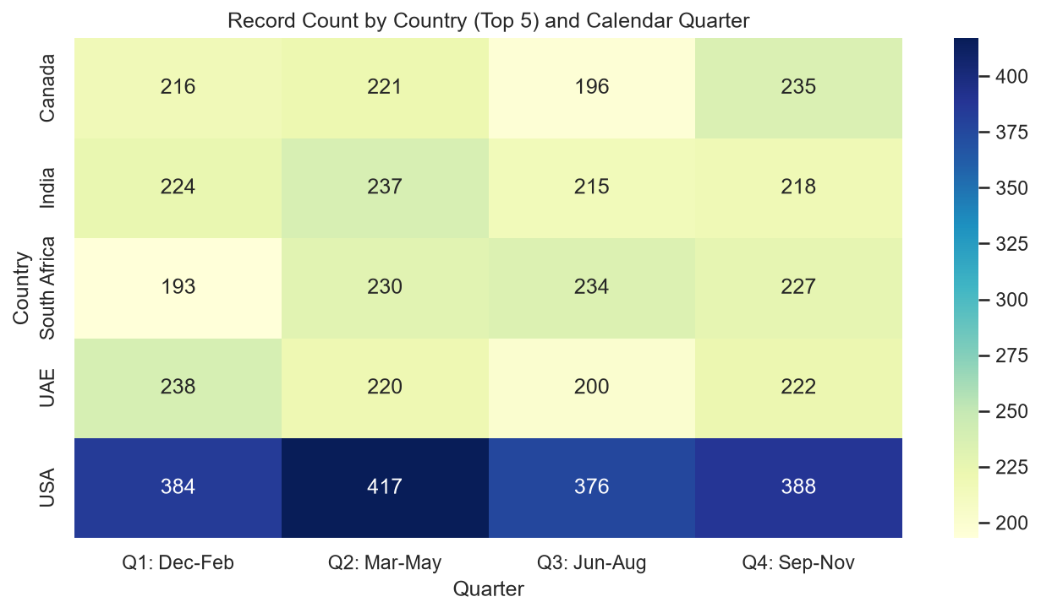
Figure 9: Record Count by Country (Top 5) and Calendar Quarter
- Record counts per country/quarter range mostly from 193 to 417. The USA's per-quarter counts (376–417) are consistently around double the other four countries counts (193–238), matching its higher overall record volume.
- Within every country, the range across the four quarters is close to even (e.g. the USA ranges only 376–417, a spread of about 10% around its own average). No country shows more or fewer records in a particular quarter. The country-level does not differ depending on time of year, again consistent with the data being randomly generated rather than reflecting a real-world reporting pattern.

4.3 Aggregation Analysis
Attribute chosen: Country, comparing average and median PM2.5, limited to the 10 countries with the most records so the comparison is fair and well sampled. Rationale: PM2.5 is the pollutant most widely used in air quality and public health reporting worldwide, and it forms the basis of most national Air Quality Index systems. That makes it the most meaningful single pollutant to compare across countries.
Table 6: Mean and Median PM2.5 by Country (Top 10 by Record Volume)
Country | Mean PM2.5 | Median PM2.5
UAE | 80.24 | 78.75
India | 79.32 | 78.69
Thailand | 78.70 | 78.66
South Africa | 78.28 | 78.24
USA | 77.19 | 76.79
Germany | 77.08 | 77.04
Canada | 76.72 | 76.11
South Korea | 76.06 | 77.23
Egypt | 75.95 | 74.59
Spain | 75.47 | 75.32

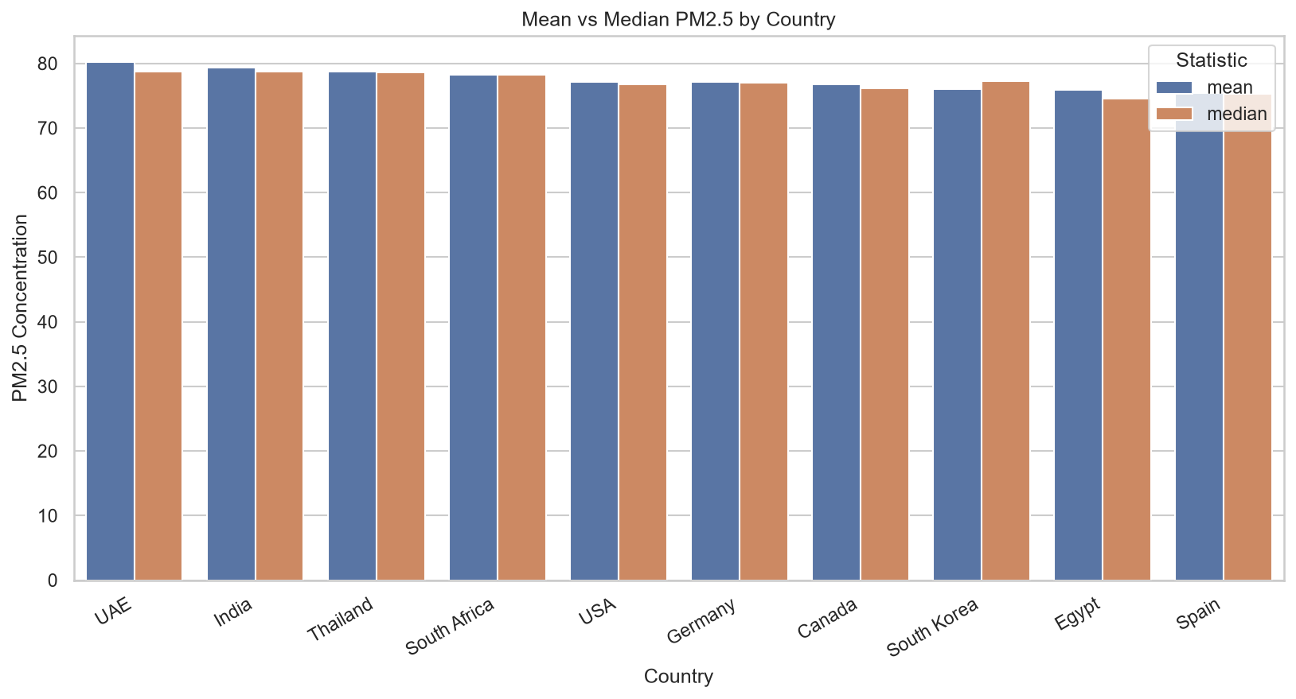
Figure 10: Mean vs Median PM2.5 by Country
- Country means range from 75.47 (Spain) to 80.24 (UAE). This is a spread of only 4.77. Small relative to PM2.5’s overall standard deviation of 40.07. No country stands out as having a meaningfully worse or better average PM2.5 than any other.
- Medians follow a similar genuinely differentiated pattern (74.59 Egypt to 78.75 UAE, a spread of 4.16). This result depended on imputing missing values within each country’s own data in one of the above sections, rather than with one shared dataset-wide value. An earlier version of this analysis imputed with a single global mean which caused every country’s median to collapse to that same repeated number. This there for masks any real difference between countries. That error was corrected before this result was produced.
- The two statistics do not always move together. South Korea has the second-lowest mean (76.06) but a higher median (77.23) than four countries with a higher mean than it (USA, Germany, Canada, Egypt). Egypt has the second-highest mean of the bottom four countries (75.95) but the lowest median of all ten (74.59). This kind of mean/median reordering is a normal sign of a slightly asymmetric sample within an individual country’s set of values. Even though the pollutant is close to symmetric in spread across the whole dataset.

4.4 Relationship / Risk-Style Analysis
We're comparing temperature (like BMI) to an air quality risk score based on PM2.5 (like a diabetes risk score). To get that score, each reading was sorted into one of six levels, using the EPA's current PM2.5 guidelines from May 2024: Good, Moderate, Unhealthy for Sensitive Groups, Unhealthy, Very Unhealthy, or Hazardous, based on set µg/m³ cutoffs. Those six levels were numbered 1 through 6 so we could average them. Temperature was split into five ranges too: below 0°C, 0–10°C, 10–20°C, 20–30°C, and above 30°C.
Table 7: Air Quality Risk Score by Temperature Band
Temperature Band | Mean Risk Score | Std Dev | Median Risk Score
< 0°C | 3.68 | 1.00 | 4.0
0–10°C | 3.59 | 1.03 | 4.0
10–20°C | 3.62 | 1.01 | 4.0
20–30°C | 3.64 | 0.99 | 4.0
> 30°C | 3.58 | 1.04 | 4.0

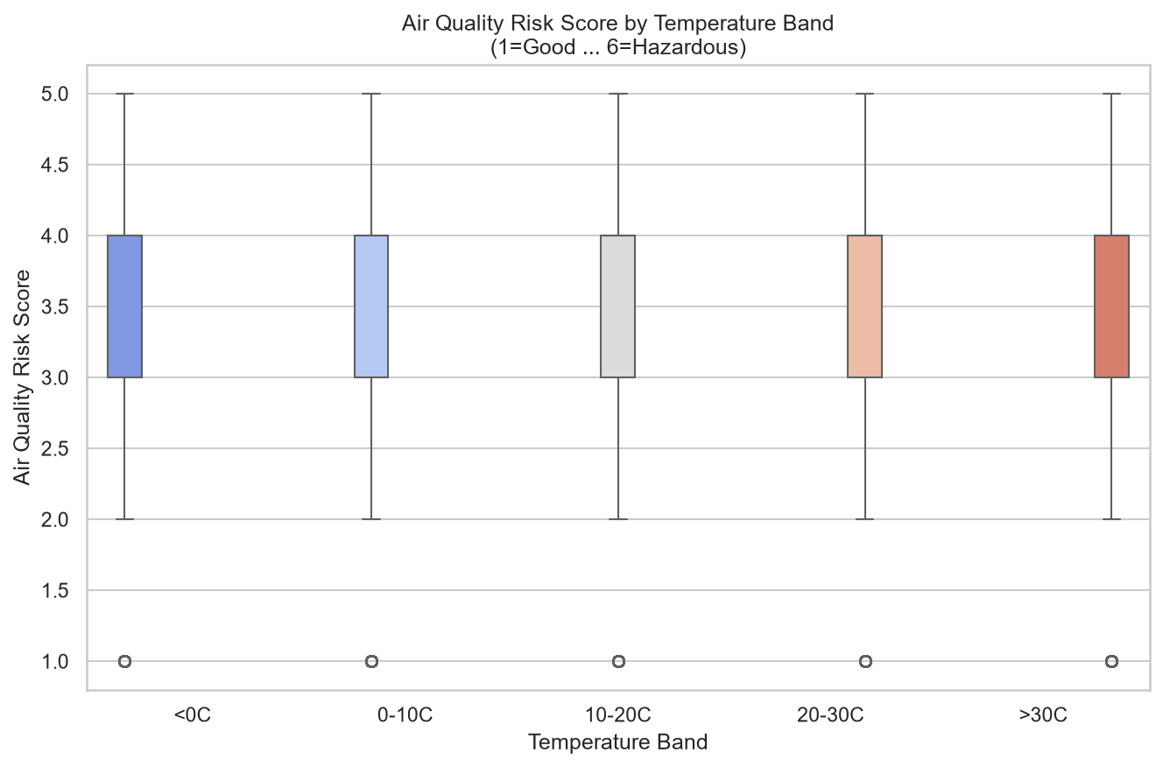
Figure 11: Air Quality Risk Score by Temperature Band
- The mean Air Quality Risk Score is essentially flat across every temperature band (3.58–3.68), the median is identical in every band (4.0, “Unhealthy”), and the interquartile range is identical in every band (3–4, “Unhealthy for Sensitive Groups” to “Unhealthy”). Temperature has no seem effects on air-quality risk in this dataset.
This analysis is still worth reporting despite the this result for two reasons:
- It rules out temperature as a reason for air-quality risk in this dataset before any further modelling is attempted. A future analyst building a predictive model of pollution risk could correctly remove temperature as a feature of proof saving effort and avoiding a incorrect relationship being assumed.
- It highlights an important limitation in how well this dataset reflects the real world. Real-world air-quality research consistently finds a relationship between weather and pollution. For example, warm air sitting on cold air cause a temperature inversion which trap pollutants near the ground in cold still conditions. A higher temperature speeds up the formation of ozone. The complete absence of any such pattern here shows that this synthetic but messy dataset does not accurately reflect real atmospheric physics. Any results or models built on it should not be assumed to generalize to real air-quality data.

5. Conclusion

Summary of Key Findings
- Pre-processing: The dataset's biggest problem was duplicates. 45.64% of all rows were exact copies of another row. City names were also a mess: casing and spacing inconsistencies had turned 20 real cities into 120 different looking entries. On top of that, about 5% of values were missing, all in the six pollutant columns. Since those columns weren't skewed, we filled the missing values with the mean rather than the median, and we used each country's own mean, not one number for the whole dataset (there's a note below on why that matters). We also checked every numeric column for outliers, using both the IQR and z-score methods, and found none. That's despite the dataset's own documentation claiming outliers were deliberately added in. The reason is that every column was generated within a narrow, evenly spread range, so nothing ever landed outside the IQR bounds.
- Univariate exploration: All nine numeric variables are close to symmetric and spread out fairly evenly. Imputation left a visible spike in each of the six pollutant columns' histograms: a tight band of about 19 similar country level values, not one exact number. Records split almost perfectly evenly across the four calendar quarters, and the USA supplies roughly double the records of any other single country.
- Multivariate analysis: No meaningful correlation exists between any pair of the nine numeric variables (the highest is |r| = 0.02). Record counts per country don't vary meaningfully by quarter. Average PM2.5 varies only modestly but genuinely across the ten best sampled countries (mean 75.47 to 80.24, median 74.59 to 78.75), and the derived air quality risk score shows no relationship with temperature band. Together, the correlation and temperature band results strongly suggest most columns in this dataset were generated independently of each other, rather than through a physically coupled process. That's an important caveat for anyone using this dataset for more than practicing data cleaning technique.

5.2 Challenges Encountered
- Duplicates: 25,375 rows shared the same City, Country and Date without being fully identical. This make it unclear whether they were genuine repeat readings or further injected noise. This was addressed by removing only exact full-row duplicates and documenting the other values rather than guessing and removing values which could be real data.
- Capitation Issues: standard title-casing turned “UAE” into “Uae”. This was addressed by first inspecting the raw unique values, then applying a small manual correction for the three affected country acronyms (UAE, UK, USA).
- Imputation side-effects: an initial version of this analysis imputed each pollutant’s missing values with one dataset-wide mean. That choice was statistically justified by the near-zero skew, but it introduced a visible spike into every pollutant’s histogram and more seriously, collapsed every country’s median PM2.5 in Section 4.3 to the same repeated number. This removed any real difference between countries. This was caught during my review rather than being left. I fixed this by imputing within each country’s own values instead of with one shared number. Section 4.3 now reports the corrected, genuinely result.

5.3 Next Steps
- If a future analysis needs less imputation driven clustering in the pollutant distributions than the tight country level band still visible in Section 3.2. We should try grouping by a finer level, like City instead of Country when filling in missing values.
- If the original data includes a station or reading ID. This would properly solve the City + country + Data duplicated values that were flagged back in section 2.2
- Since none of the variable in this version of the data st show no correlation we should repeat this analysis on the original non messy Kaggle dataset. This would show whether the independence is real or just a result of the messy generated version. This need to be done before any predictive modelling is done.

References
- WAQI786. (2023). Global Air Quality Dataset [Data set]. Kaggle. https://www.kaggle.com/datasets/waqi786/global-air-quality-dataset
- Coffxc12 (Alish Dahal). (2023). Global Air Quality 2023 – Messy Version [Derived data set, based on WAQI786's Global Air Quality Dataset]. Kaggle.
- United States Environmental Protection Agency. (2024). AQI Breakpoints [Data table, effective 6 May 2024]. EPA Air Quality System (AQS). https://aqs.epa.gov/aqsweb/documents/codetables/aqi_breakpoints.csv
- pandas development team. (2024). pandas documentation: Working with missing data. https://pandas.pydata.org/docs/user_guide/missing_data.html
- Waskom, M. (2021). seaborn: statistical data visualization. Journal of Open Source Software, 6(60), 3021. https://seaborn.pydata.org/

